ISSN 2709–3662 (Print)

ISSN 2709–3670 (Online)

https://doi.org/10.52587/JAF050104

*Journal of Agriculture and Food*

*2024, Volume 5, No.1, pp. 53-68*

**Prospects and scope of Groundnut mechanization: A review**

Abu Saad1, Zia-Ul-Haq1*[ORCID](https://orcid.org/0000-0002-1865-5182), Syed Mudassir Raza2, Muhammad Adnan Islam3, Ibrar Ahmad5, Shahid Javed Butt4, Muzammil Hussain3, Khurram Sheraz6, Aksar Ali Khan1,Tajwar Alam7

**Abstract**

Groundnut is popular for its versatile usage including direct human consumption as a dry fruit and the production of oil as it has an important nutritional value for human and animal consumption in the form of silage, hay, oil seed cake, etc. Historically, the groundnut fields were prepared by bullock-drawn tillage implements, sown manually or by bullock-drawn drills, intercultural practices with small tools or hoes, harvested, striping, and pods collected manually. Several factors prevent the farming community from adopting modern agricultural technology. Normally farmers in undeveloped countries are hesitant to adopt new technologies. Different technological interventions were made by different researchers in terms of seedbed preparation, sowing, intercultural, plant protection, harvesting and threshing, oil extraction, and butter making to avoid the challenges involved with the traditional method. Therefore, this study presented the results of the technological interventions made by different researchers, and the limitations of these technologies were also identified which can be used by farmers to enhance groundnut production. By using these mechanized technologies, farmers can complete their tasks within time to avoid the losses from late sowing and conventional harvesting practices of groundnut

***Keywords:*** Harvesting; Mechanization; Production; Processing;

Article History: **Received:**; 12 January 2024 Revised: 10th April, 2023; Accepted: 15rh July, 2024

**Introduction**

Groundnut was first times domesticated in Paraguay’s valleys. Its plant is an annual herbaceous with a growing height of 30-50 cm. Many other local names including ground nuts, earthnuts, monkey nuts, goober peas, pygmy nuts, and pig nuts are also used to denote peanuts. The peanut is a legume, not a nut despite its appearance and name (Rajasekar et al. 2017). Groundnut is the sixth largest oilseed crop worldwide. It has protein and fat contents of 26-28% and 48-50%, respectively, and a high concentration of vitamins, minerals, and dietary fiber. The growth of groundnut is preferred in soil with good drainage, a loose texture, and a sufficient amount of minerals, especially potassium, calcium, and phosphorus. It’s grown in more than 100 countries in the world. About 94% of total world production received from 97% of areas lies in developing countries (Bharath et al. 2020).

In Pakistan, groundnut is grown in rain-fed areas, including districts Chakwal, Jhelum Attock, Rawalpindi, Swabi, Karak, and Sanghar. The cultivation of groundnut occurs on an area of 94 thousand hectares, with a total production of 101 thousand tons and a total yield of 1.1 tons/ha approximately. The *Pothwar* region of Pakistan majorly contributes (82.8%) to the production of groundnut. During harvesting, groundnut losses may range from 10 to 30% depending on the soil texture, moisture level, groundnut variety, and time of harvesting. Traditionally, farm workers have to pick the pods by hand. The early and late sowing activities have resulted in a very poor average yield of groundnuts in Pakistan. The main factors that are affecting groundnut productivity are exceptional environmental conditions and low input use by farmers. A long, hot climate with ideal rainfall of 500mm and a range of temperature between 25-30°C are the requirements for appropriate growth of groundnut (Ali & Ali 2020).

The climate in the *Pothwar* region is varied in terms of both rainfall and temperature. The productivity of agriculture in this region is comparatively low due to several factors including lack of seeds, inefficient use of fertilizer, lack of irrigation water, variation of seasonal rainfall, drought, insufficient research work, and ineffective extension services (Qasim et al. 2016). Several factors prevent the farming community from adopting modern agricultural technology. The production of groundnuts has declined due to a lack of seeds, expensive inputs, lack of knowledge, limited financial choices, and disease and pest infestation. Normally farmers in undeveloped countries are reluctant to adopt new crops (Mehmood et al. 2021).

Different machines are fabricated for shelling various crops. The use of these machines is not economical as they raise production costs and reduce profit. Locally, hand-operated concave or semi-rotary shelling machines are very common. Since there was no expelling unit, separation was accomplished by winnowing. The shoe's semi-rotary motion shells the pods alongside the screen. That machine's main fault was that it required a lot of labor and took a long time. That machine processed 60 to 80 kilograms every hour. The hopper, separation chamber, crushing chamber, and blower unit are all part of this machine. Additionally, it is electrically operated, which saves time and has a significantly increased shelling capacity. As well as being lightweight, the device is simple to use and maintain, and the spare components are locally available (Bharath et al. 2020).

For groundnut production, the majority of farmers prepare the field with the help of tine cultivators regardless of the crop cultivated and some farmers use rotavators, which are essentially secondary/intercultural equipment. The groundnut crops required better tillage and a friendly atmosphere to expand roots and flourish crops. Crops cultivated in such an environment will be limited in their ability to grow beyond the level of loose soil since the activity of such machinery cannot break open hard pans. Thus, the groundnut production system is essential for primary tillage operations. The use of primary tillage equipment is necessary to break open the compacted soil up to a depth of 30-45 cm and to give a soft, friable soil base for proper plant growth (Krishnaprabu, 2019).

**Seedbed Preparation**

In field preparation for groundnut sowing some farmers utilize less intrusive tilling techniques, clearing the field with a non-selective herbicide (such as glyphosate or paraquat), and then slightly putting seeds into the soil. As long as fields are free of weeds and groundnuts start to emerge, both techniques can be successful. Still, other farmers don't even touch the soil, which frequently requires the use of herbicides to manage weeds. Even if the farmer removes the weeds later in the season and weeds are not properly controlled, they can compete with groundnut seedlings and reduce groundnut yield. The frequency of plows used to prepare the seedbed as well as the seed rate significantly impacted groundnut yield. The production increased by 2.56% for every 1% increase in plow application. These findings suggest that growers were conscious of the benefits of better preparation of land for groundnut. Additionally, the availability of appropriate soil moisture is a requirement for the production of major inputs which is restored before to rainy season through properly prepared fields. Farmers were also using the proper seed rate. According to the regression analysis, a 1% increase in seed rate resulted in a 0.64% increase in yield (Qasim et al. 2016).

For attaining optimum production of groundnut deep seedbed without compaction layers or a hardpan is necessary. This indicates that conservation agriculture is less effective for peanuts than traditional tillage. Deep tillage breaks the hardpan, burying weeds, decreasing the chance that they will become a problem later, and making the soil more permeable to roots and pegs, making it easier to remove the pods from the ground during harvest. Both flat soils and ridges are suitable for growing groundnuts. If it has problems with water logging then ridges are recommended. Additionally, ridge-grown groundnut typically produces larger yields. This is most possible because of the looser soil, which endorses better roots and pod production. Double rows of groundnuts can be planted along box ridges that are 75 cm apart with a 30 cm row spacing. This causes the soil to quickly cover itself, shading out weeds in the process. Tied ridges can be utilized to save moisture if water shortage is projected to be a problem by lowering runoff and increasing percolation (Desmae and Sones 2017)

**Groundnut sowing methods**

A manually drawn single-row groundnut planter was developed and tested at the actual field condition. The newly developed planter contained a main frame, a furrow opener, an adjustable handle, drive wheels, a seed hopper, a seed tube, and a seed metering device. A pair of ball bearings, acrylic sheets, mild steel bars, and other locally accessible materials were used for the fabrication of most of the components. During field testing machine field capacity and efficiency were found to be 0.0675 ha/h and 80.3% when operated at a speed and working depth of 2.1 km h-1, 55mm. It was also found that the maximum seed damage and seed missing index were 4% and 4.6%, respectively. The manually operated groundnut planter works with accuracy has a lighter weight, is simpler to use, and requires no maintenance (Madhusudan and Preetham, 2020).

A planter is usually required for groundnut production this expensive machine is out of the range of small land holdings farmers which causes a reduction in potential yields. For the small land-holding farmers, a better manual two-row groundnut planter (Figure 1) was developed with the help of material purchased from the local market. The main frame, handle, furrow opener, discharge tube, hopper, roller housing, and metering unit are all components of the machine. At various forward speeds, the machine's field capacity and metering efficiency (3-hole metering devices) were evaluated. The machine field capacity efficiency was found to be 82% at 0.7 m/s machine speed, and the maximum metering efficiency of 92% was observed using standard error bars. According to the ANOVA (analysis of variance), speed has a significant impact on metering efficiency. An average of five seeds per point could be planted by this planter (Sedara et al. 2020).

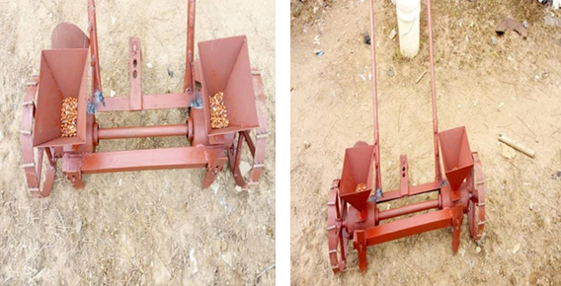

**Figure 1.** Sowing of groundnut seeds

In a study, it was assessed the quality of mechanized peanut sowing and digging activities that were operated manually and automatically. The treatment included two digging operations, one with and one without an autopilot, and two forward speeds (4.5 and 6.0 km/h). The analyzed variable was used as a quality indicator in the experiment and was carried out in medium-textured soil with a completely randomized design set up in bands. The parallelism between the tractor-sower set's passes during sowing was assessed at 120 points for each system (manual and automatic routing). At 15 points per treatment, the two guidance systems analyzed the digging losses at two forwarded speeds (4.5 to 6.0 km/h). It was found that engaging the autopilot enhanced the parallelism between the passes of the tractor-sower set and the quality of the operation. The amount of digging lost did not affect forwarded speed. The visible digging loss did not differ, however, the operation's quality improved when it was carried out on autopilot. When the digging was done with automatic routing, minor undetectable and total digging losses were obtained, and better quality was observed at a speed of 4.5 km h-1; however, quality was negatively impacted under manual operation. Autopilot is therefore a useful tool for increasing operational quality and precision (Zerbato et al. 2019).

A 4-row low horsepower tractor-drawn groundnut planter was developed and tested its field performance. The planter's row-to-row distance was 30 cm and used inclined plate techniques of the metering system. With a power transmission ratio of 1:41, power is transferred from the ground wheel to the metering system by using chains and sprockets. To open the furrows, a double-pointed shovel-style furrow opener was provided. The seed is sown in the furrows with a 10.1 cm seed spacing and at the desired depth of 4.5 cm. The tractor with 18-24 horsepower can run this implement. The planter's field capacity was determined to be 0.24 ha/h at an operating speed of 2.88 km/h, with a field efficiency of 69.44% (Reddy et al. 2017).

Large-scale mechanized peanut sowing operations are not suitable in hilly and mountainous regions due to scatted and small land holdings. In this study, a mechanism for sowing spraying film on peanuts was designed. The seeding, ditching, spraying, and film-covering systems are some important components that are designed for peanut seeding spraying and film-covering machines. According to field tests, the peanut sowing spray coating machine developed using this method can easily carry out sowing operations in hilly and mountainous areas and attain sowing efficiencies of 0.26 to 0.33 ha/h, which can significantly increase farmer's productivity, reduce operating costs, and decrease labor requirements (Liu et al. 2021).

In a study, a sensor-based groundnut planter mounted with a mini tractor was developed. The main working principle of the mini tractor-mounted groundnut planter with a site-specific precision water applicator is that an infrared (IR) sensor may detect dropped seed from the planter's metering mechanism and trigger a solenoid valve to release water close to the dropped seed. This technique allows for the simultaneous application of water and seeding in a single operation. This raises the soil's moisture content and the ability of seeds to survive and germinate. With the use of this technique, the farmers can plant the crop even in dry conditions (low soil moisture content) by applying water together with the seed at the desired depth (Anitha & Kumar 2022)

**Plant protection practices**

For simultaneous planting of groundnuts and herbicide treatment, an herbicide spraying attachment was developed and connected behind the existing inclined plate-type groundnut planter. For seed sowing, power is transferred from the ground wheel to the metering system by chain and sprockets, and for herbicide spraying, from the P.T.O shaft to a single axial piston type pump via belt drive. A covering device is used to cover the seed at the desired depth in the furrows. After that, the soil is immediately preserved with herbicide. Planter-cum-herbicide sprayer was driven with the help of 35 horsepower tractor. The machine's field capacity was determined to be 0.47 ha/h, with an operating average speed of 3 km/h and an application rate of herbicide 1100 liters/ha. The machine's field efficiency was calculated to be 65%. By comparing the planting groundnut with a local manual seed drill and then using a power-operated knapsack sprayer for herbicide application, using a planter-cum-herbicide sprayer saved 21.87 man-hours per hectare of groundnuts (Reddy et al. 2015).

Although farmers prefer to use a flat fan nozzle for peanuts, other nozzles such as dual jets, conical, and air induction may offer similar or better spray deposits. When compared to hollow cone and air induction nozzles on single and twin-row planting methods, traditional flat fan nozzles had a lower average spray deposition at the bottom of the peanut canopy. The results were shown significantly different when applying pest control and peanut yield between applications using traditional flat fan and air induction nozzles. Therefore, on peanut plants, the non-air induction nozzles had a lower level of spray deposition (Virk et al. 2021).

In China, herbicide spraying before or during sowing is the main method used to manage weeds in peanut crops. During the peanut crop's prevention, disease, pests, and weed control are of significant importance. Self-propelled boom sprayers (Figure 2) are currently utilized and have the benefit of uniform spraying that reduces droplet drift. It can be used to spray peanuts in the field after being converted into a double spray system and an isolation device. This kind of equipment often has a two-fold spray system and a baffle that is parallel to the machine's driving direction and perpendicular to the ground. It can be ideal for the strip intercropping necessities of groundnut with varying planting widths by altering the placements of the spray head and baffles. A self-propelled maize and groundnut/soybean strip intercropping boom sprayer was utilized to spray groundnut in the field. This machine has a dual spraying system that has been modified and an isolation device. Modifying the spray head and baffle settings can meet the necessities for spraying growth regulators, insecticides, and herbicides in maize-peanut strip intercropping (Yang et al. 2023).

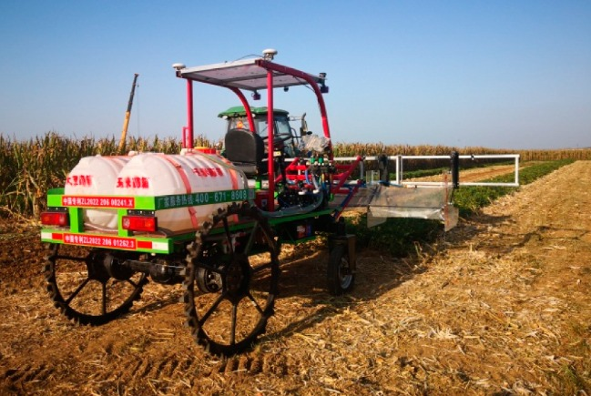

**Figure 2.** Boom sprayer for the groundnut plants

**Weed control management**

In groundnut, weeds are controlled mostly either manually or mechanically. First-hand removal of weeds is done at about 20-25 days after the sowing date and afterward repeated at 12-15 days intervals till cover of full canopy. Using manually operated tools like a wheel push hoe, weeds can also be controlled in groundnut. Hand-picking individual weeds is one of the most effective ways to manage weeds, especially when there is a sufficient availability of labor. Another frequently used efficient method for weed management in an inter-row crop is hand weeding with a hoe. Precise interculturing using flat sweeps set to run shallowly in the middle of two rows is recommended (Figure 3). The manually operated implements like star weeder and various hoes are cooperative in intercultural operation and these implements are more economical than manual weeding (Jat et al. 2011).

A study was conducted to examine the effectiveness, energy consumption, efficiency, and cost of four different weeding techniques in northern Iran. The weeding techniques were manual weeding using a wheel cultivator, conventional weeding (hand weeding with a trench hoe), and two power tiller operated weeders (weeding using power tiller powered cultivator and Rotavator at three forward speeds of 1, 1.5, and 2 km h-1). The findings showed that the power tiller-operated rotavator with a forward speed of 2 km/h had the maximum work capabilities in the first and second stages of weeding, which averaged 8.10 and 7.80 h/ha, respectively. In manual cultivator weeding, the lowest energy usage was obtained as (307.8 MJ h-1). The findings also showed that the power tiller-operated rotavator had the highest benefit/cost ratio at forward speeds of 1, 1.5, and 2 km h-1. The best way to weeding groundnuts was the power tiller-driven rotavator moving at 1 km h-1 (Firouzi & Alizadeh 2012).

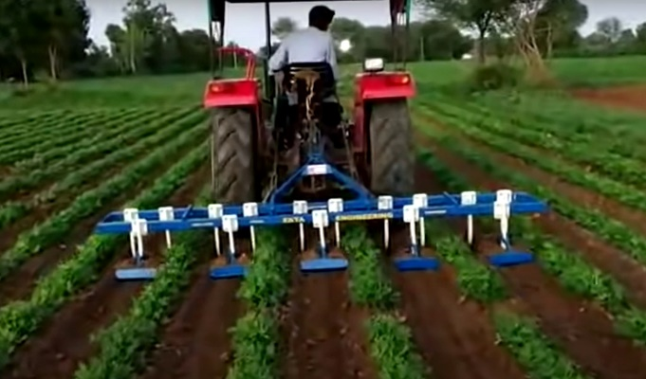

**Figure 3.** Intercultural practices in groundnut crop

**Harvesting methods**

Harvesting can be done in two different ways: manually or mechanically. Groundnut is manually pulled and turned over by using the conventional method. Generally, 12 to 14 workers are required per hectare of land to harvest groundnuts in a single day. When the crop has matured and the soil has become too hard, it can be quite challenging to physically harvest groundnuts. At these times, hand hoes or blade harrows should be used (Rajasekar et al. 2017).

In Pakistan, harvesting is presently conducted through manual labor or with the utilization of outdated models with huge grain quality and quantity losses (Khan et al. 2024). When it comes to ergonomics, groundnut harvesting is a tedious task. As a result, blood pressure, body temperature, and even heart rate will change during that time as you pull pods from the plant in the field. People are getting more joint pain during the harvesting of groundnut crops. Therefore, the development of a machine must solve this issue which could reduce workload and fatigue in the agricultural area (Ugwu and Oluka, 2015).

As the urban population increases day by day, it needs to develop the tools for rural communities to supply food and vegetables to the population. Therefore, the adoption of more advanced technology in agriculture will boost productivity and lead to the development of effective tools and production methods for groundnuts. Utilizing machinery, the groundnut (peanut) drill, starter, combine Sheller, and toaster can enhance production while lowering harvesting costs by up to 32% (Negrete 2015). The conventional method for harvesting groundnut requires extra time, even though the effort is more than the cost of labor, and the profit margin is relatively low. By using machinery, human labor is reduced, efficiency is increased and hence profit is increased. Sometimes it takes 20 to 30 persons to strip 1 acre of groundnut pods (Andhale et al. 2017). For harvesting one hectare of groundnut, 100 workers per day are required as each pod must be manually picked. This manual operation is expensive and time-consuming, especially during labor shortages. Due to the time and labor requirements of the current groundnut harvesting method, farmers with 50 hectares of land are unable to complete their groundnut harvesting before October. However, after October, unharvested groundnut pods start to germinate and the leaves also start to turn brown (Saakuma et al. 2016).

The digging of soil by using a groundnut digger is the first step in the two-stage harvesting process. To get the pods' moisture content under 20%, the peanut plants were allowed to dry out in the field for three to five days. After that, finish the pick-up, pod-picking, cleaning, and collection processes by utilizing the picking-up peanuts harvester. It is possible to use a stationary peanut picker to pick, clean, and collect dry peanut plants manually. It’s a tractor-mounted machine with a working width of 1400 to 1700 mm. It can complete the soil cleaning, digging, and laying of two ridges of groundnut instantaneously (Yang et al. 2023). Conventional groundnut digger blades are labor-intensive, time-consuming, and have high yield losses (up to 28.26%) while with precision digger inverter (Figure 4), the pod losses declined up to 4.75% (Husain et al. 2024).

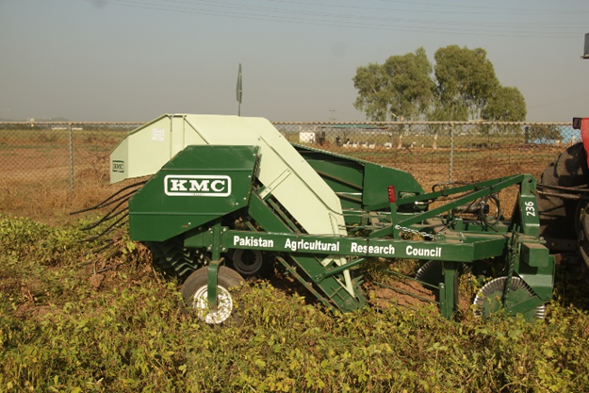

**Figure 4.** Precision digger inverter for groundnut harvesting

Most of the roots and the entire plant are removed from the soil for harvesting of groundnut. The fruits' wrinkled shells are restricted between pairs of 1-4 seeds per pod in each pod-sized fruit. Two stages of harvesting take place: the first one is mechanized systems, in which a machine is used to cut through the soil slightly below the level of the peanut pods and remove the main root of the peanut plant. To prevent the peanuts from falling into the ground, the machine lifts the "bush" off the ground, shakes it, and then flips it over. This enables the peanuts to gradually dry over the passage of 3-4 days after harvesting. Typically, harvesting involves a succession of tasks such as digging, lifting, windrowing, stocking, and threshing. Depending on the system used, some of these tasks may be combined or removed. The most time-consuming and expensive field operation related to groundnut growing is harvesting. The particular harvesting technique used depends on the variety of groundnuts cultivated. In bunch-type cultivars, the growth of the pods is restricted to the plant's base, and the pegs that carry the pods into the soil are substantial and healthy (Rajasekar et al. 2017).

**Striping of pods**

After harvesting Approximately 3 to 5 weeks are required to strip the pods when the moisture content of the pod has stabilized at 10%. This process involves separating the pods from the vines, which are the vegetative components of the plants. Manual stripping was normal in traditional farming techniques. Pods are individually separated from the vines, which causes them to dry quickly and stabilize at a moisture content of 6-8%. To reduce pod damage and Aspergillus flavus contamination, this method is utilized to produce edible or confectionary groundnuts. There are various ways to remove pods from the vines. In the bunch type, the plants are piled high with the exposed pod end. Within a week, the pegs grow brittle, and the pods must be manually peeled. In some areas, the plant's pods are beaten against a crossbar to loosen the pods after they have been pulled out of the ground and dried in the field. During this technique, some pods sustain damage but this technique is not very expensive. For most varieties of groundnut, a basic comb-style stripper and peddle-operated stripper are provided (Rajasekar et al. 2017).

The pod stripping machine (Figure 5), which is made of a wire spike-type cylinder operated by an electric motor, is appropriate for stripping groundnut pods from harvested crops. Striping can be done by manually holding a part of a bunch above a spiky cylinder. At a time three people can work at this thresher. Additionally, a blower and sieve are included for separating the pods from the plant stalk, leaves, etc. In comparison to the traditional way of stripping, it saves 50% of operating time, 40% of labor, 30% of the cost of operation, and 4% of the losses. The output capacity was recorded at 120 kg ha-1 with 98% cleaning efficiency 100% and stripping efficiency (Krishnaprabu 2019).

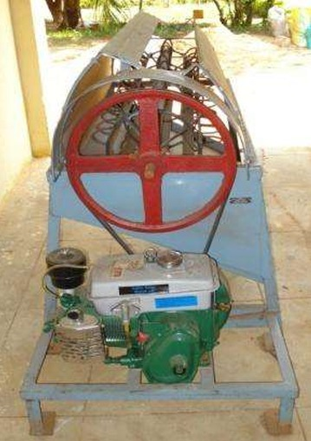

**Figure 5.** Pod stripping machine

**Threshing practices**

Threshing is the process of separating grains from chaff, straw, and impurities. Traditional threshing was accomplished with the help of sticks and animals but nowadays modern machines are used for this purpose which are called threshers. Small farmers usually do this work by hand, using rakes and sticks. For the removal of the vegetative part from the plant, the crop is left inverted in the field for some days and when the pods become hard then they are removed from the plant with the help of groundnut threshers. Most of the threshers used for groundnut threshing are axial flow types in which the plants move parallel to the beater axis. Any dirt or unwanted material falls onto a sieve from where they are ejected out of the thresher with the help of a blower and the pods are collected from the grain outlet (Rajasekar et al. 2017).

Farmers require time-saving equipment that is suitable for their requirements and to manage harvest and post-harvest tasks for groundnut crops. A 50-horsepower tractor was used to evaluate the performance of the groundnut thresher (Figure 6). The experiment was conducted for the groundnut varieties GG-20 and GG-22 of the Virginia bunch type at the Cotton Research Centre and Instructional Farm of the College of Agricultural Engineering and Technology, Junagadh Agricultural University. The reported output capacities for the GG-22 and GG-20 varieties were 524.66 kg h-1 (cylinder speed was 292 rpm) and 407.60 kg h-1 (cylinder speed was 421 rpm), respectively. The proportions of blown pods, un-threshed pods, broken pods, and spilled pods were recorded at 14.51%, 18.92%, 0.126%, 6.07%, 14.59%, 0.361%, and 0.99% respectively. The average threshing and cleaning efficiency was determined 81.08%, 88.21%, and 85.41%, 88.74%, respectively (Amrutiya et al. 2020).

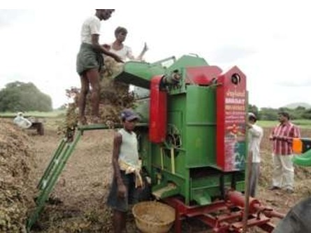

**Figure 6.** Groundnut thresher

In another experiment, the parameters used to assess the performance of the groundnut thresher included crop moisture content, grain size, angle of repose, spherical, thousand-grain mass, density, and coefficient of friction as well as threshing efficiency, threshing capacity, germination rate, cleaning efficiency, grain breakages, and fuel consumption. As crop moisture content increases, threshing and cleaning efficiency, threshing capacity, and grain density all decrease. The moisture content was increased along with the other parameters stated above. Thresher performance was a combined mean analysis of variances that were significant at (p 0.05). In this study, 14% moisture content was recommended because it had better results as compared to other moisture levels. The threshing capacity at 14% moisture content was (208.750, 285.45, and 68.181) kg h-1 and the threshing efficiency (98.603, 99.330, and 99.49%) and cleaning efficiency (97.101, 98.22, and 93.731%) were recorded (Belay & Fetene 2021).

**Grading technology**

Grading and handling standards for groundnuts were developed in the 1960s in the United States quota groundnut program. The process of grading is the sorting of the grains into specified categories. Grading ensures product quality by removing any undesirable components and classifying standardized quantities of products according to the requirements. The grading techniques (Figure 7) of farmers depend upon the standards and demands of the market based on physical properties. Size, color, weight, shape, moisture content, texture, and unwanted materials are examples of physical qualities. Chemical qualities may include the product's composition, rancidity, or color. Biological features include the type and quantity of any insect or mold damage as well as the germination rate of the pods. Usually, groundnuts are graded based on their weight and size. The grading of pods by weight is performed with the help of weight graders, while size graders use sieves, diverging belts, or bars (Fashina et al. 2015).

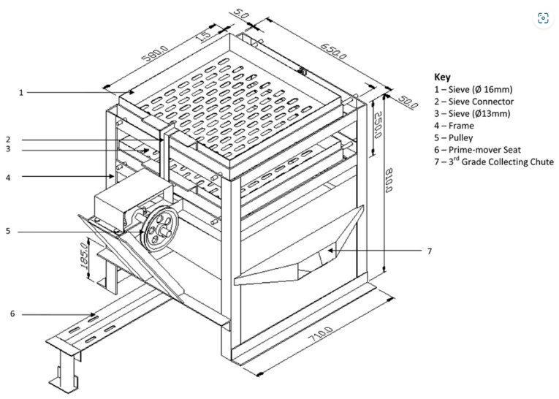

**Figure 7.** Groundnut pod grading machine

It might be challenging to grade the product by using just the human eye. The grading procedure requires a lot of time, so labor costs will be higher. Additionally, there is a possibility to mix up different fruit sizes. Manual grading requires a lot of work, takes a lot of time, and is not consistent. Different individuals observe the quality of the product in different ways, hence it becomes uncertain to uniformly grade the product. To overcome the above-mentioned factors, the mechanical grader is a suitable choice that preserves product uniformity and increases the value of the graded product (Easackha et al. 2020).

**Port-harvest Processing**

A groundnut shelling machine (Figure 8) was designed and fabricated by Raghtate & Handa, (2014). Various experiments were conducted to evaluate its performance. The work performed by this machine was more economical because it was designed for small farmers. This machine shells groundnuts more quickly and economically as compared to manual shelling operations. The groundnut sheller machine significantly reduced the cost and time, which are the most important factors in any system. Walke et al. (2017) designed and fabricated an electrically operated groundnut machine. Power is supplied to the motor, which operates the machine. The groundnuts are delivered to a crushing chamber through the hopper where they are crushed between a semicircular net and a roller to separate groundnut seeds from their shells.

To shell groundnut pods and separate kernels, a hand-operated groundnut decorticator can be used. It consists of a handle and an oscillating unit with a sieve at the bottom. The oscillation unit has several hard rubber or cast iron lined assemblies installed. The shells are removed by rubbing the groundnut pods against the fixed perforated concave sieve and oscillating unit. The perforated concave sieve allows the decorticated shells and kernels to fall. At the bottom of the machine, the kernel and shells are gathered and manually separated. Concave sieves are also changeable depending on the size of the pod, and clearance between the concave and oscillating unit can be adjusted (Krishnaprabu, 2019).

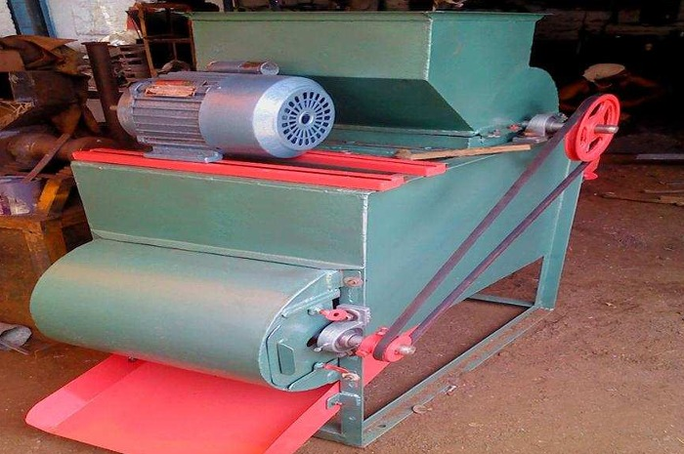

**Figure 8.** Groundnut shelling machine

Nirmale et al. (2017) designed and developed a roasted groundnut peeling machine operated electrically, the testing and analysis parameters of groundnut with size variation, strength of compression, temperature of roasting, and time of roasted peanut. In his research, bold-type peanuts were selected since they are mostly used in the food and sweet industries due to their higher compression strength and because 60% to 70% of all peanuts consumed are bold-type nuts. Additionally, it is longer and sweeter than others. During testing, a mass of 5.042 kg of roasted peanuts on average was fed into the machine, producing a mass of 3.989 kg of peeled roasted peanuts, 0.605 kilograms of peanuts that were unpeeled, and 0.448 kg of broken peanuts on average. An efficiency of 79.129% and an average time of 248 seconds were noted. The developed machine had a capacity of peeling 75 kg h-1 and was simple to use. Since the machine only weighed about 18 kilograms, it can be used everywhere and can be transported anywhere.

Moyana & Mushiri (2018) developed a peanut butter machine (Figure 9) designed for small-scale farmers. This machine had a total power of 1.1 kilowatts and it can grind 56 kilograms of peanuts in one hour. To reduce maintenance costs, an air fan with a 1.5 horsepower motor was used. In an experiment to check the moisture content in roasted peanuts, it was found that they need to have a 2% moisture content to make high-quality peanut butter. According to Bond's equation, it takes 157.13 KJ/kg of energy to crush roasted peanuts. The amount of power required depends on how much moisture is present in the peanuts, their size, and the type of peanut. The 100 mm stainless steel plates were used for grinding peanuts because they don't wear out easily and don't get damaged by rust.

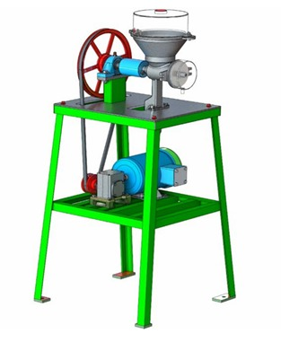

**Figure 9.** Peanut butter making machine

Each stage is very important and for this purpose, the entire sector is implementing strategies for mechanization of the whole production process for more economical, time-saving, and sustainable processes (Khan et al. 2023).

**Conclusions**

The problems faced by groundnut growers in traditional methods enforce technological interventions. These interventions may be in the form of machines that can promote the work feasibility such as; seedbed preparation, sowing, intercultural, plant protection, harvesting, threshing, oil extraction, and butter making. By using machinery, the farmers can save their time to complete their above-mentioned essential tasks but it’s also necessary to enhance machines ‘efficiency by modifying them. Market required graded produce while there is no grading system at the farm level, the cleaning and grading of the groundnut is performed by the human eye or rarely by using small portable machines. The intervention of a grading system with a groundnut thresher may facilitate this task so that the farmers can grade their produce in a single operation which can save their time and cost. The lack of postharvest processing technologies is the main barrier for industries to make byproducts like peanut butter. Engineers and researchers should develop butter-making machines for small-scale industries to enhance the byproducts of groundnuts.

**References**

Ali, B., & Ali, Q. (2020). Evaluation of optimum sowing dates for newly developed lines of groundnut in Rainfed areas of northern Punjab. *Evaluation,* 5(1).

Amrutiya, M. D., Makavana, J. M., Kachhot, A. R., Chauhan, P. M., & Tiwari, V. K. (2020). Performance Evaluation of Tractor Operated Groundnut Thresher. *Current Journal of Applied Science and Technology*, 38(6), 1-15.

Andhale, A. S., Wajahat, S., Lawhale, P., Mendhe, K., & Tufail, M. S. (2017). Design and Development of Groundnut Pod Separating Machine. *International Journal of Latest Engineering and Management Research,* 2(04), 38-40.

Anitha, G., & Kumar, A. A. (2022). Mini Tractor-mounted Sensor-based Aqua Groundnut Planter. *Agricultural Mechanization In Asia, Africa And Latin America,* 53(1), 22.

Belay, D., & Fetene, M. (2021). The effect of moisture content on the performance of melkassa multicrop thresher in some cereal crops. *Bioprocess Engineering*, 5(1), 1-10.

Bharath, K. V., Priyanka, C., A, S. K., Sharu, S., & Subashree, S. (2020) (August). Design and Fabrication of Groundnut Pod Separator. *International Journal of Science and Engineering Research (IJ0SER,)* 8(8), 6-9.

Desmae, H. & Sones, K. (2017). Versio Green Orang Versio Dark g Light g Groundnut cropping guide. *Africa Soil Health Consortium*, http://exploreit.icrisat.org

Easackhan, A., Geetha, R., & Amutha, C. M. R. (2020). Standardization of Sieve Size for Grading of Sesame Seeds (Sesamum indicum L.) Var. TMV-7. *Int. J. Curr. Microbiol. App. Sci*, 9(7), 850-855.

Fashina, A.B., Saleh, A., & Akande, F.B. (2015). Development and evaluation of a groundnut in-shell grader. *Agricultural Sciences*, 6(02), 217.

Firouzi, S., & Alizadeh, M. (2012). Evaluation of different weeding methods for groundnut in northern Iran. *African Journal of Agricultural Research*, 7(8), 1307-1311.

Husain, M., Haq, Z.U., Mahmood, H. S., Jahanzaib, M., Islam, M. A., Niazi, B.M.K., Ali, M.M., Saad, A., Khan, A. A., & Nawaz, Q. (2024). Performance Evaluation of Precision Groundnut Digger-Inverter. *Agricultural Sciences Journal*, *6*(2), 17–26. https://doi.org/10.56520/asj.v6i2.413

Ibrahim, M. M., Amin, E., & Farag, A. (2008). Developing a multi purpose digger for harvesting root crops. *Misr. Journal of Agricultural Engineering*, 25(4), 1225-1239.

Jat, R. S., Meena, H. N., Singh, A. L., Surya, J. N., & Misra, J. B. (2011). Weed management in groundnut (Arachis hypogaea L.) in India review. *Agricultural Reviews*, 32(3).

Khan, A. A., Zia-Ul-haq, Asam, H. M., Khan, M. A., Zeeshan, A., Qamar, S., & Saad, A. (2024). Performance Evaluation of Half-Feed Rice Combine Harvester. *Proceedings of the Pakistan Academy of Sciences: Part A*, *61*(1), 81–88. <https://doi.org/10.53560/PPASA(61-1)858>

Khan, A. A., Zia-Ul-haq, Islam, M. A., Saad, A., Raza, S. M., Ali, I., Sheraz, K., Usman, M., Ali, M. M., & Ali, M. (2023). Prospects and Scope of Olive Mechanization: A Review. *Zoo Botanica*, *1*(2), 79–93. https://doi.org/10.55627/zoobotanica.001.02.0613

Krishnaprabu, S. (2019). Primary, I. (n.d.). Mechanization Tools in Groundnut Cultivation. Vol. 1, edition 1. www.isco.co.in.

Liu, M., Li, Q., Jin, J., & Li, R. (2021, October). Design of peanut sowing spraying film covering machine. *In International Conference on Mechanical Engineering, Measurement Control, and Instrumentation* (Vol. 11930, pp. 1028-1033). SPIE.

Madhusudan, B. S., & Preetham, M. (2020). Design, development and performance evaluation of manually operated groundnut planter. *Indian Journal of Ecology*, 47(3), 858-862.

Mehmood, K., Rehman, A., & Khan, A. (2021). Farmers' Perceptions, Awareness and Adoption of Improved Groundnut Varieties in Potwar Plateau of Pakistan. *Sarhad Journal of Agriculture,* 37(4). 1364-1376.

Moyana, B., & Mushiri, T. (2018). Design of an automated peanut butter making machine in developing countries. *Proceedings of the International Conference on Industrial Engineering and Operations Management Pretoria / Johannesburg, South Africa,* October 29-November 1, 2018.

Negrete, J. C. (2015). Current status and strategies for Harvest Mechanization of peanut in Mexico. *SSRG International Journal of Agriculture & Environmental Science*, 2(1), 7-15.

Nirmale, V. M., Khade, D. P., Jamdagni, R. U., Nalwade, S. V., Adadande, A. S. (2017). Design and Development of Peanut Peeling Machine, *International Journal For Research & Development in Technology,* 7(4), (April-17) ISSN (O) :- 2349 - 3585.

Qasim, M., Bakhsh, K., Tariq, S. A., Nasir, M., Saeed, R., & Mahmood, M. A. (2016). Factors affecting groundnut yield in Pothwar region of Punjab, Pakistan. *Pakistan Journal of Agricultural Research,* 29(1).

Raghtate, A. S., & Handa, C. C. (2014). Design and fabrication of groundnut sheller machine. *IJIRST–International Journal for Innovative Research in Science & Technology*, 1(7).

Rajasekar, M., Arunkumar, S., & Divakar, S. (2017). Santosh kuamr R, Design fabrication and performance analysis of groundnut thresher. *International Research Journal of Engineering and Technology,* 4(2), 1631-1637.

Reddy, K. M., Kumar, D. V., Reddy, B. S., & Ramana, M. V. (2017). Design And Development Of Low Hp Tractor Drawn Inclined Plate Groundnut Planter. *Angrau*, 260(60), 39.

Reddy, K. M., Kumar, D. V., Reddy, B. R., Reddy, B. S., Reddy, G. A., & Munaswamy, V. (2015). Design and development of herbicide spraying technology while in sowing for groundnut. *Progressive Agriculture*, 15(1), 21-27.

Sedara, A., Lanwo, R., & Sedara, O. (2020). Development of a Low Cost Two-Row Groundnut Planter. *Turkish Journal of Agricultural Engineering Research*, 1(2), 324-338.

Shahir, S., & Thirupathi, V. (2009). Performance evaluation of a divergent roller grader for selected vegetables. *AMA, Agricultural Mechanization in Asia, Africa and Latin America*, 40(4), 60–62.

Ugwu, K. C., & Oluka, S. I. (2015). Ergonomic Comparison of Two Groundnut Harvesting and Shelling Methods. *Int. J. Technol. Enhancements and Emerging Engineering* *Res*, 3(7), 43-47.

Virk, S. S., Prostko, E. P., Kemerait, R. C., Abney, M. R., Rains, G. C., Powell, C. T., & Tyson, W. G. (2021). On-Farm Evaluation of Nozzle Types for Peanut Pest Management Using Commercial Sprayers. *Peanut Science*, 48(2), 87-96.

Walke, T., Gadge, P., Gohate, G., & Banpurkar, R. (2017). Design & fabrication of groundnut sheller machine. *International Research Journal of Engineering and Technology (IRJET)*, 4(3), 1606-1610.

Yang, H., Sun, W., Wu, F., Xu, H., Gu, F., & Hu, Z. (2023). Determination of Planting Pattern and Screening of Agricultural Machineries for Maize-Peanut Strip Intercropping: A Case Study in Henan Province of China. *Sustainability*, 15(10), 8289.

Zerbato, C., Furlani, C. E., Oliveira, M. F. D., Voltarelli, M. A., Tavares, T. D. O., & Carneiro, F. M. (2019). Quality of mechanical peanut sowing and digging using autopilot. *Revista Brasileira de Engenharia Agrícola e Ambiental,* 23, 630-637.

**Citation**

Saad, A., Ul-Haq, Z., Raza, S.M., Islam M.A., Ahmad, I., Butt, S.J., Hussain, M., Sheraz, K., Khan, A.A., Alam, T. (2024). Prospects and scope of Groundnut mechanization: A review. *Journal of Agriculture and Food, 5(1)*, 53–68.

s